Motion | Tp(s) | f(rad/s)
Surge | 115 | 0.055
Sway | 125 | 0.05
Heave | 31.4 | 0.2
Roll/pitch | 32.7 | 0.19
Yaw | 7.5 | 0.838
Wave: 0.44
Cased 1 All blades are feathered V=38.7, Hs=12, Tp=14.2, wavedir0 and wave dir90
Wave dir=0
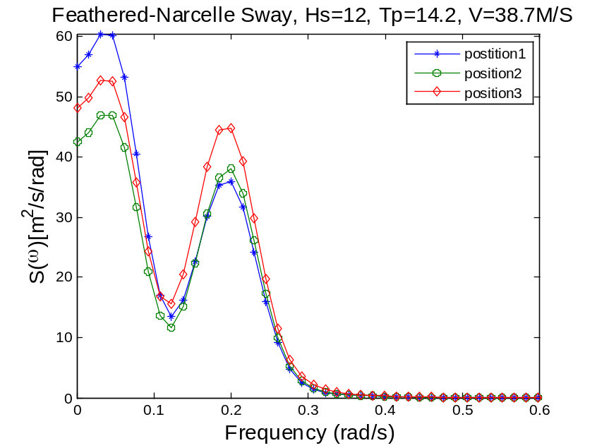
wp1: sway wp2: roll
wave dir=90
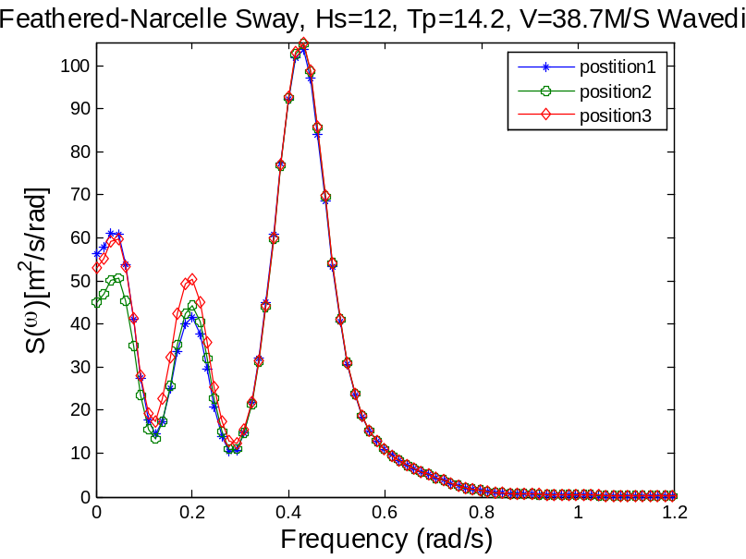
The feathered blades excited wave-induced response
Wave dir=0
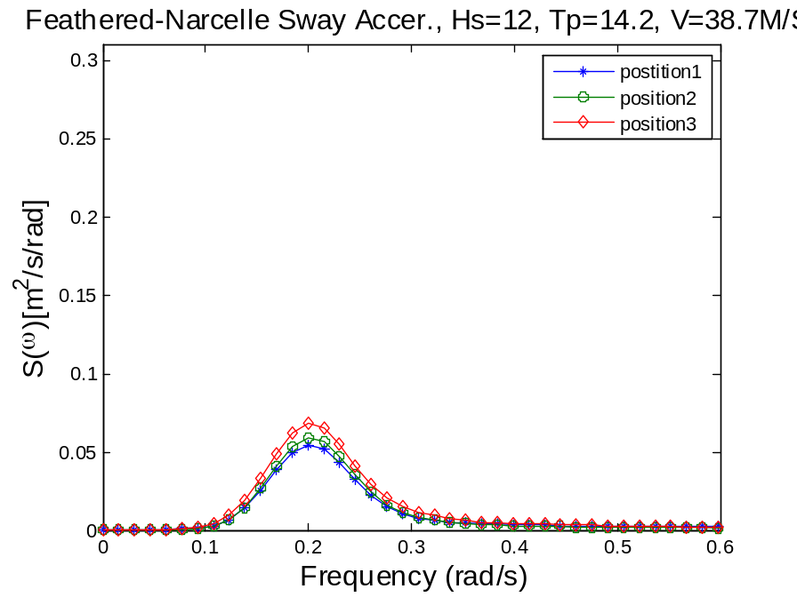
Wave dir=90
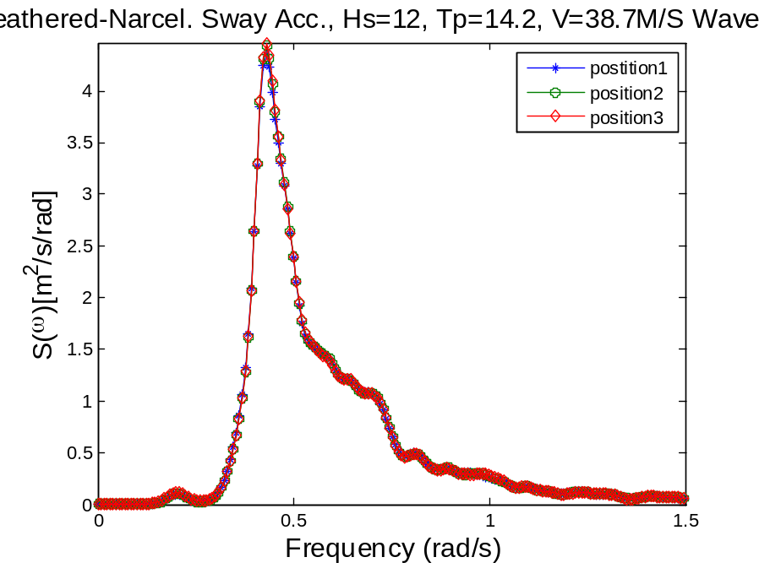
Wp1 roll wp2:wave

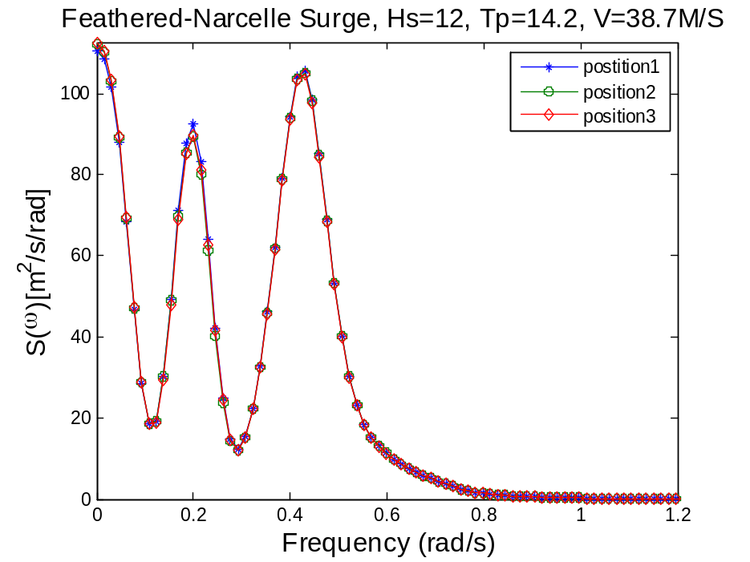
Wave dir=90
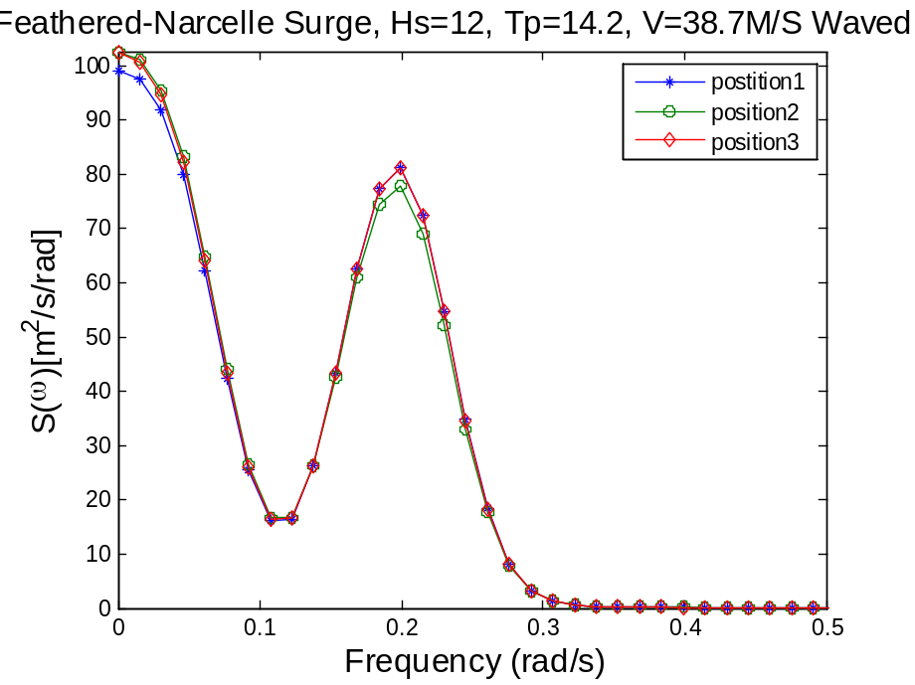

Wave dir=0
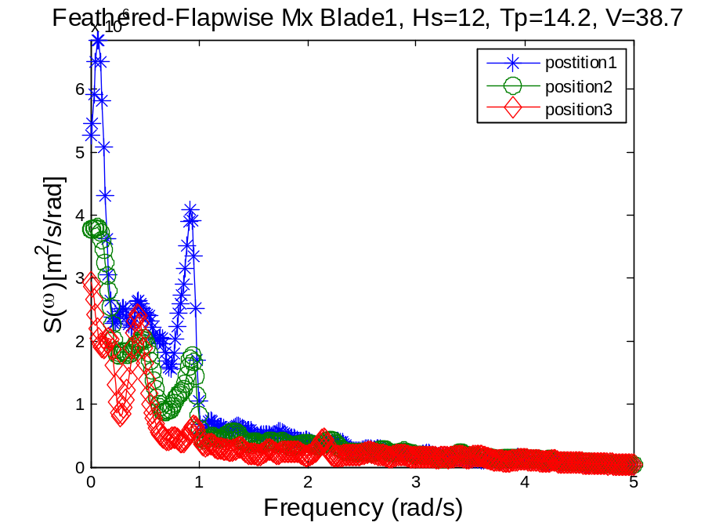
Wave dir=90
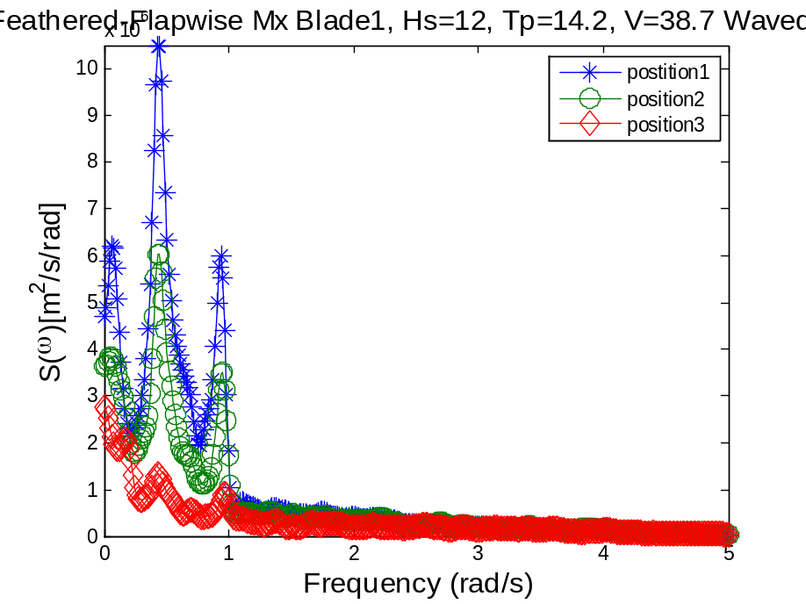
Wave dir0
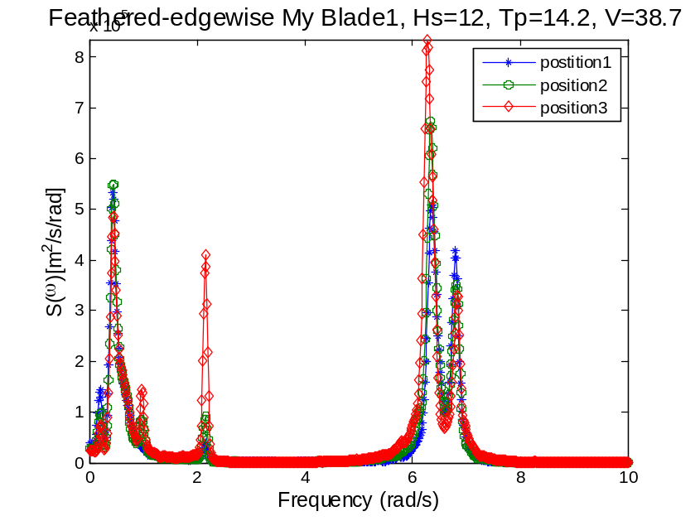
Wp1: wave induced wp2: first nat. blade
Wave dir 90
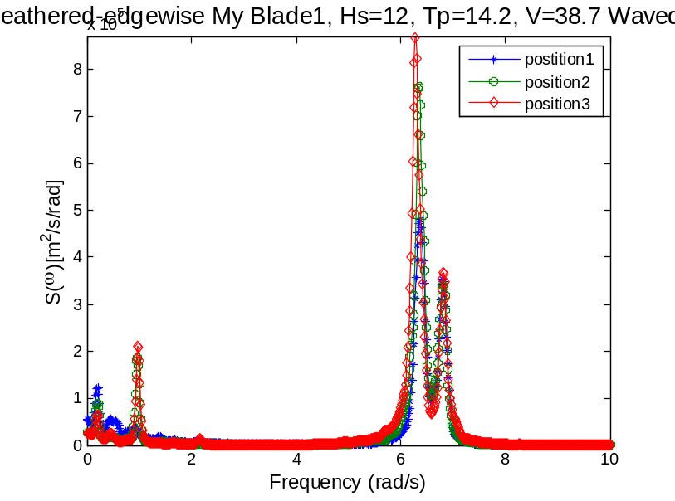
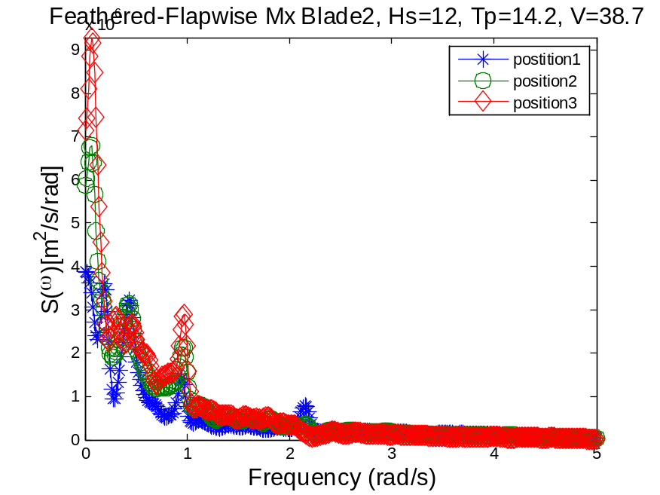
Wave dir0
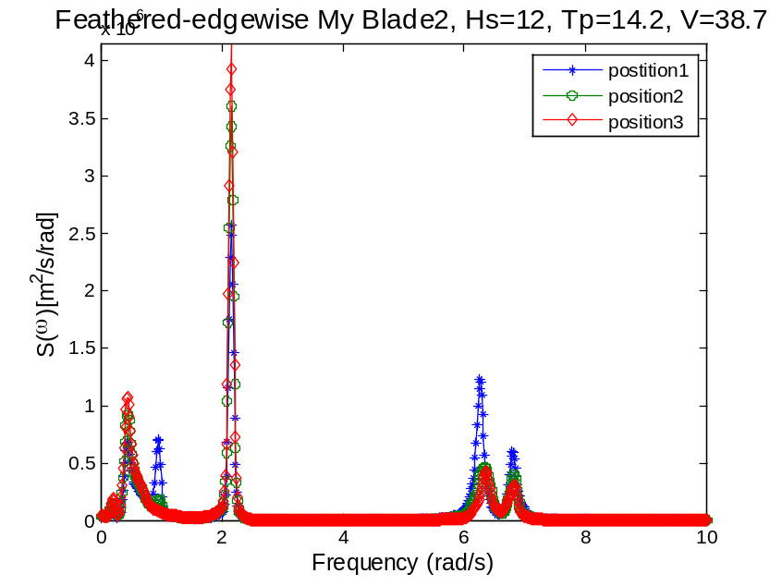
Wave dir90
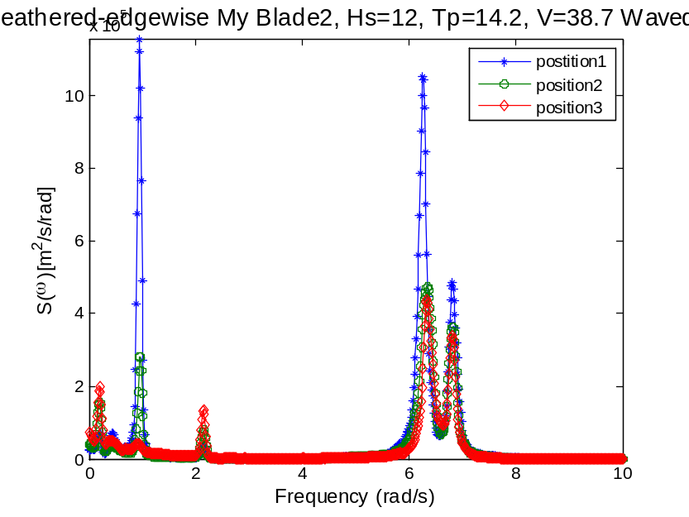
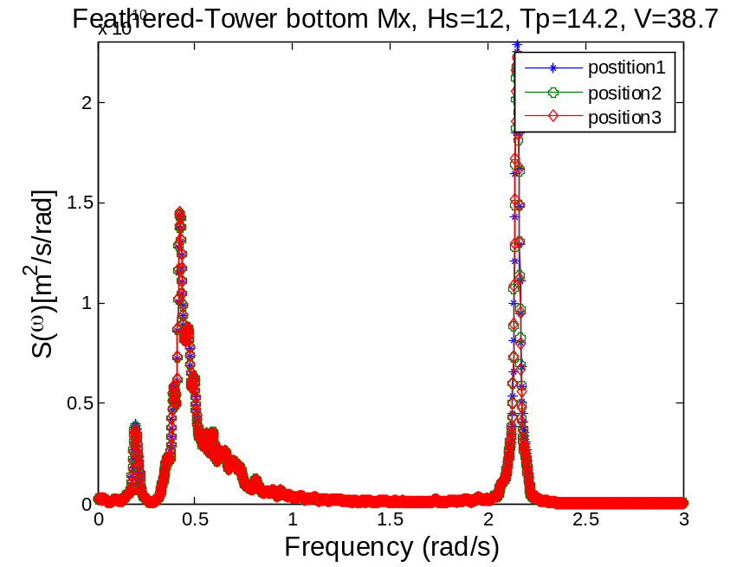
Wave dir90
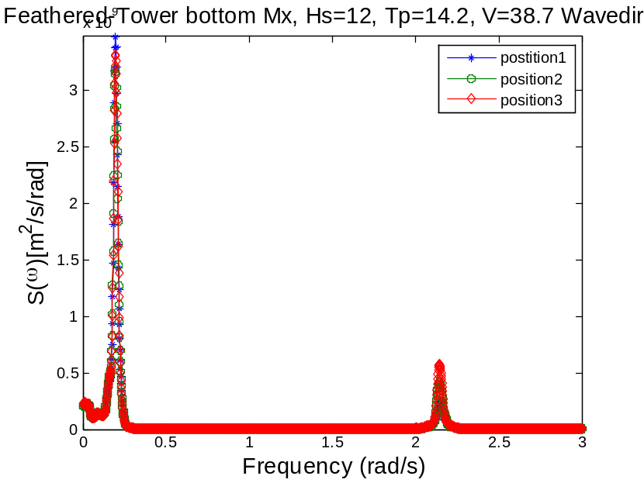
Wp1=0.2, pitch
Wave dir0
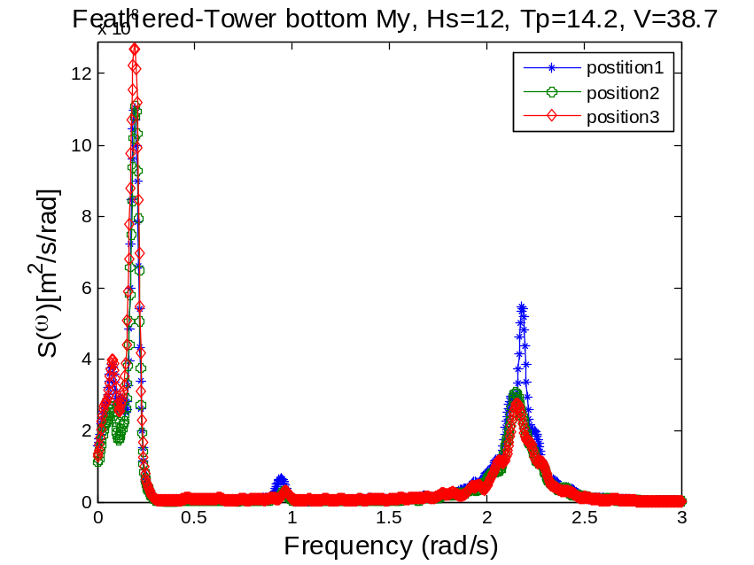
Wave dir90

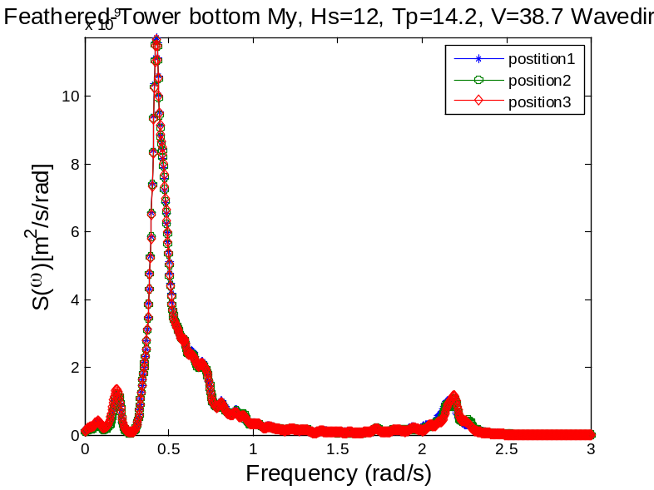
Wave dir0
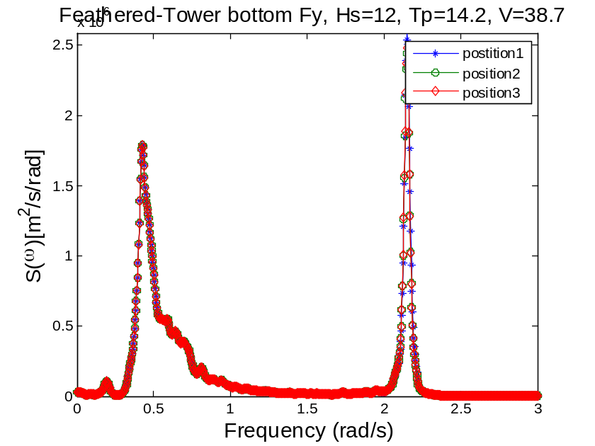
Wave dir90

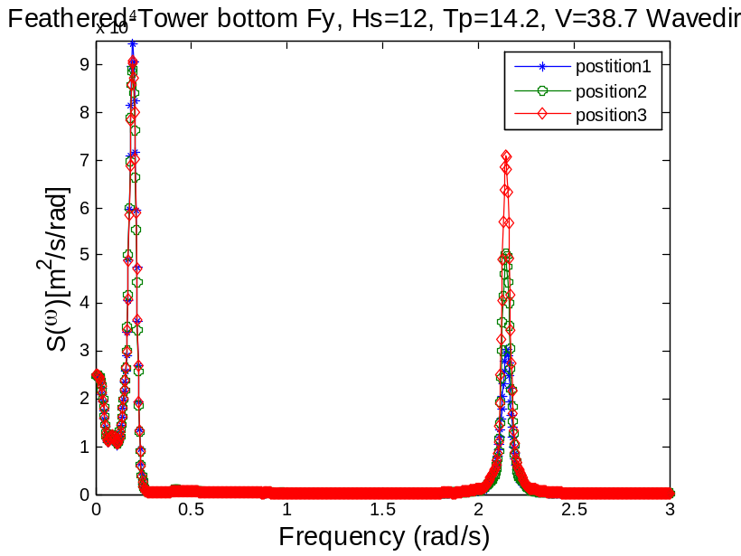
Wave dir0
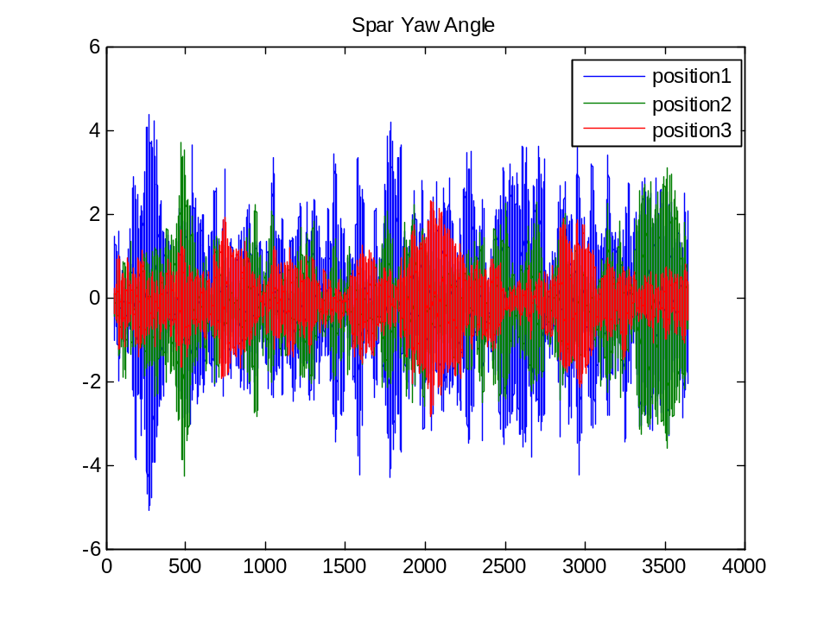
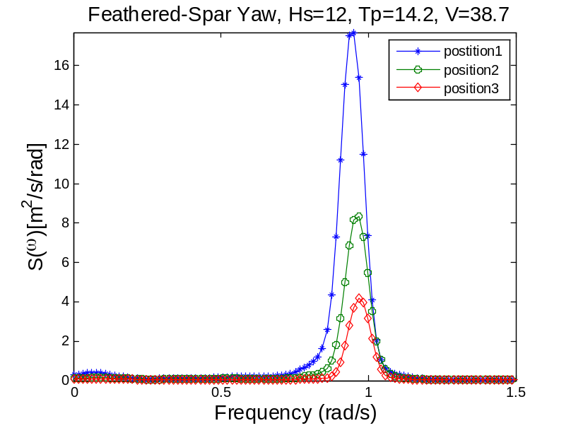
Wave dir90
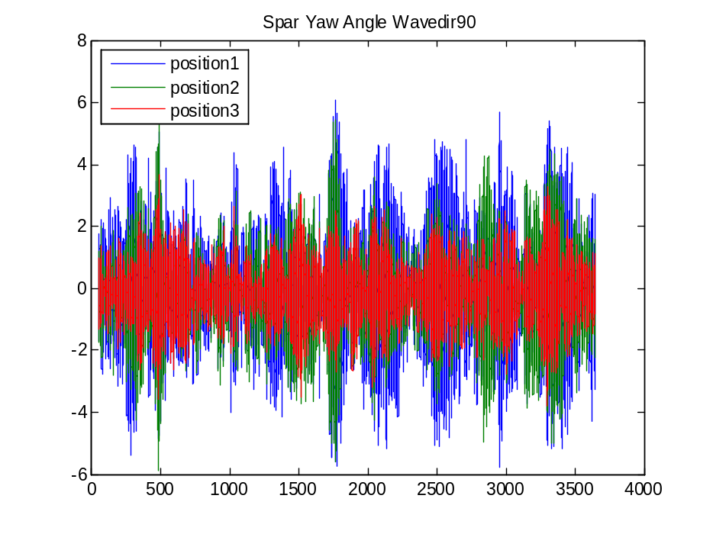
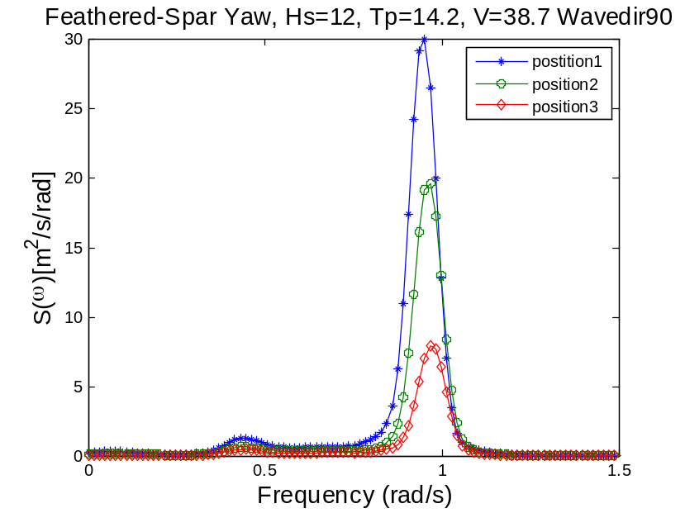
Wave freq. is present in the yaw motion
Wavedir 0
Yaw resonance freq. =0.93, higher than the calculated nat. freq.
No other frequency is present.
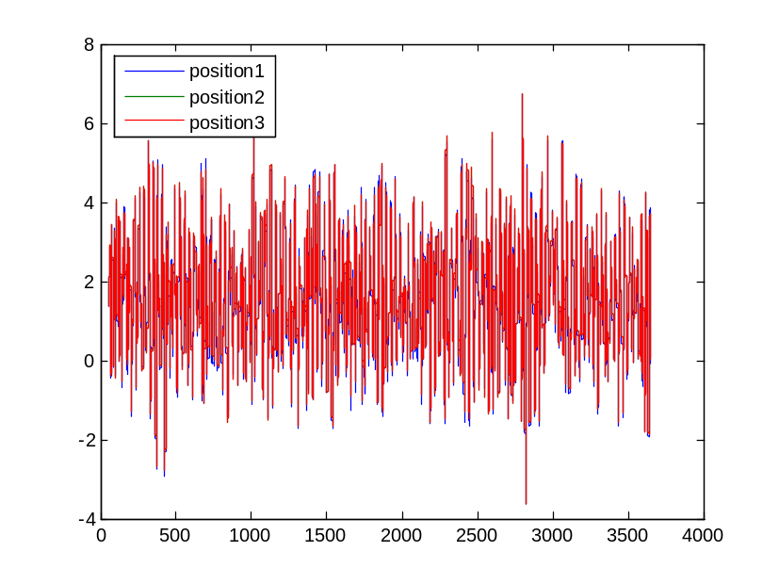
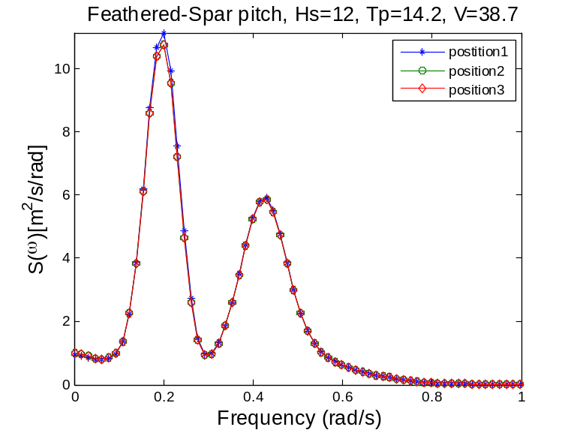
wp1: pitch wp2: wave
wave dir90
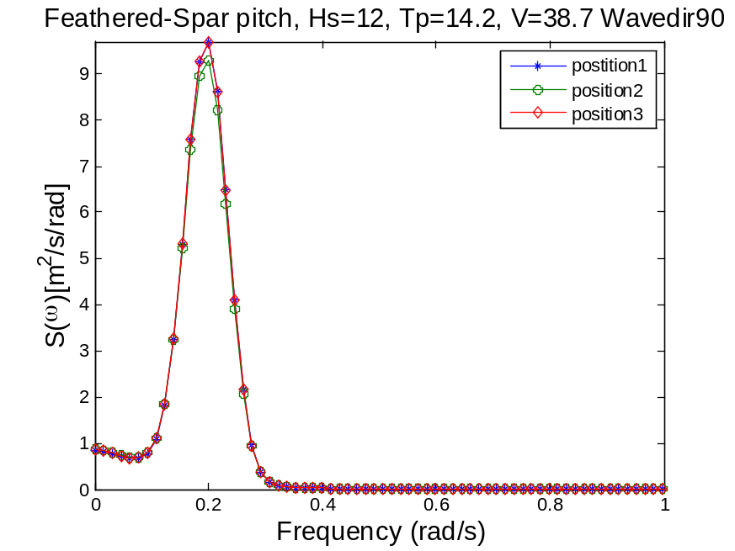
No wave freq. is present in the response
Vx blade1 r=60m
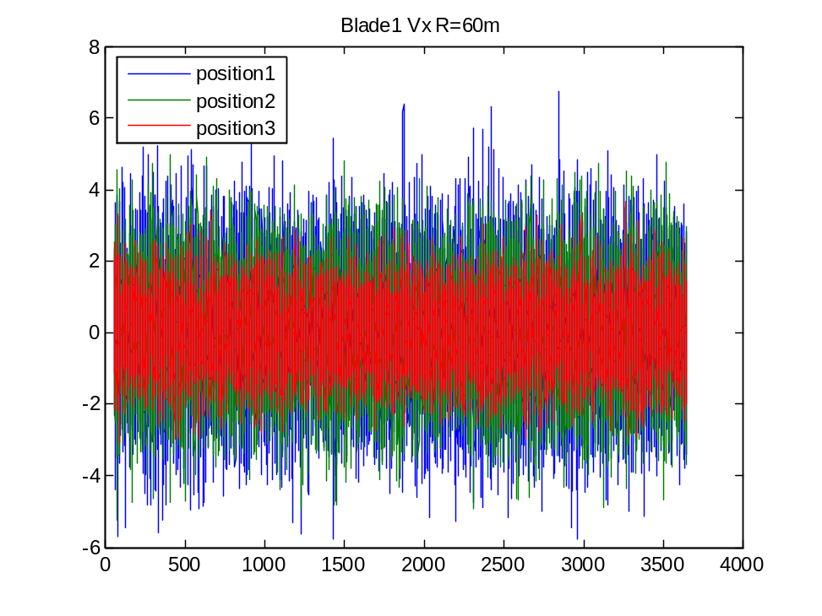
Wave dir0
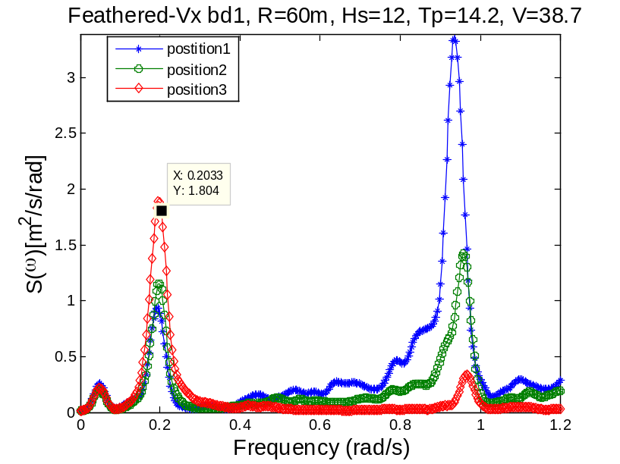
Wave dir90
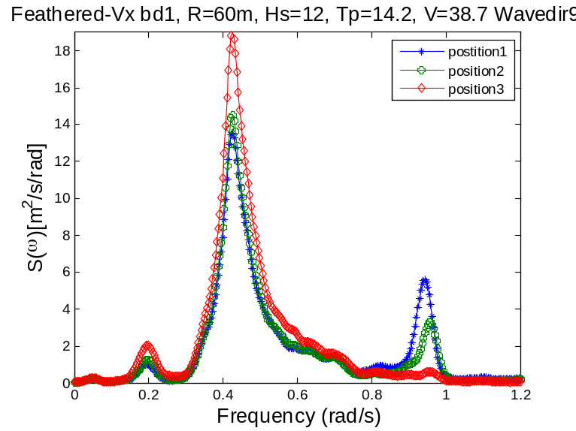

Vy blade1 r=60m
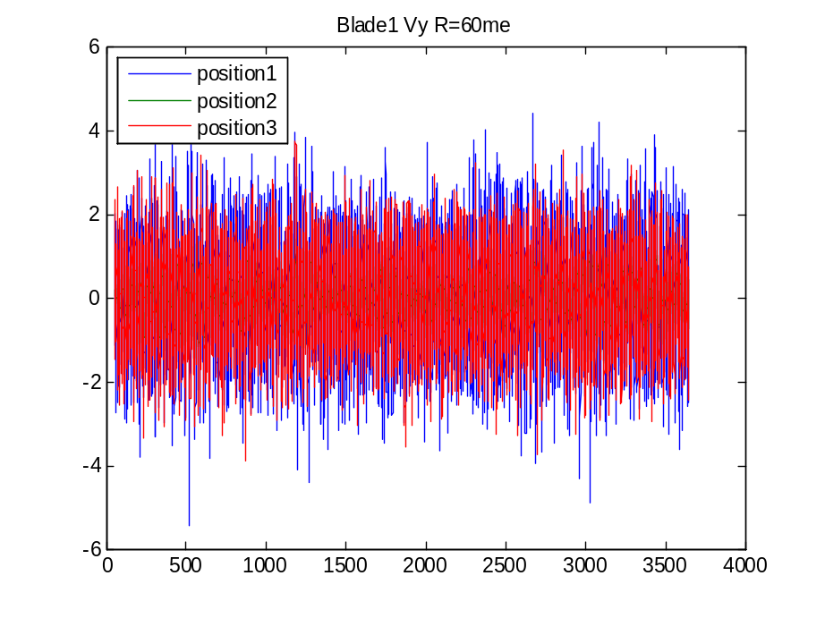
Wave dir0
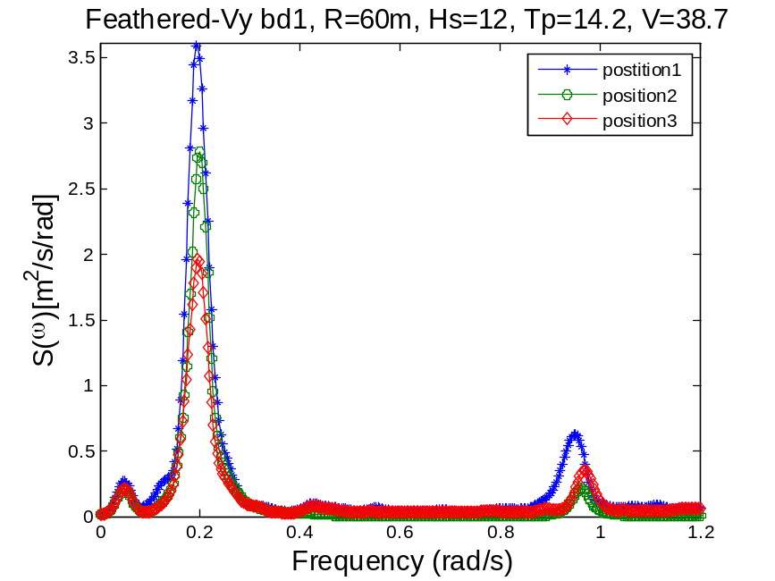
Wp1 pitch wp2 yaw?
Wave dir90
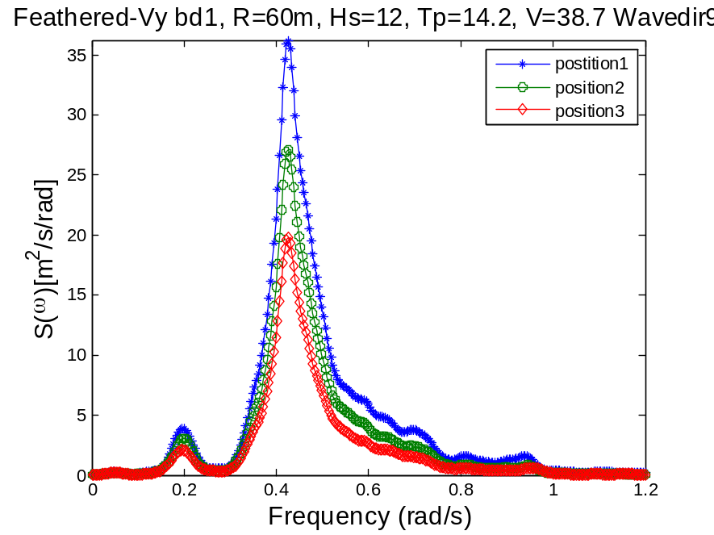
Wp1: pitch wp2: wave freq.
Wave dir0
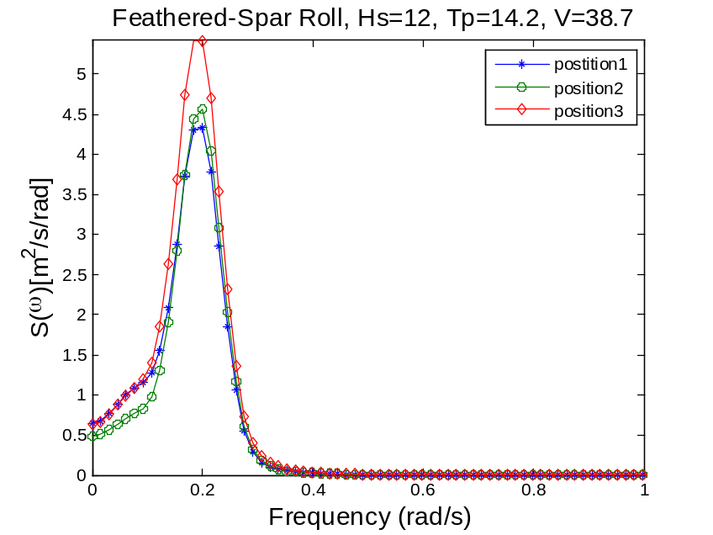
Wave dir90

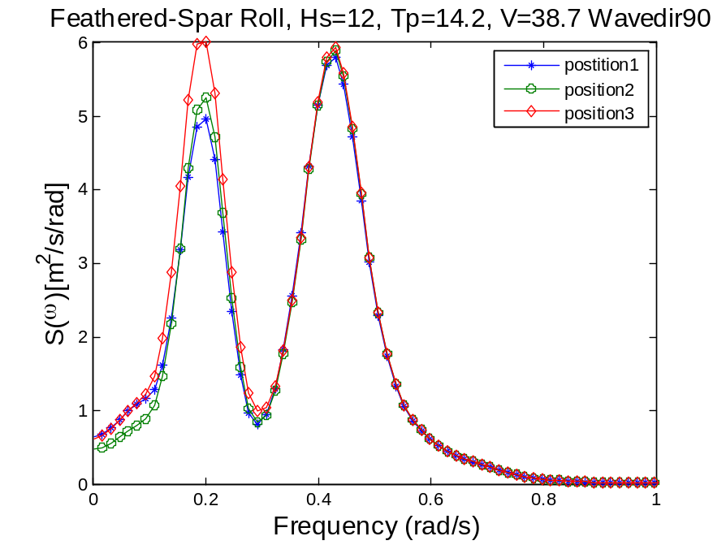

Dynamic response of the feathered case, wave dir0 and wave dir90
The response spectrums are sensitive to the wave direction. The wave resonance response will be unaffected by the change of azimuth angle. Yaw angle is most susceptible to the blade azimuth position, position 1 gives the largest response. No wave-induced peak is present in the yaw response is the direction is 0 but slight wave resonance is observed at 90 deg wave angle. The symmetrical position3 leads to the lowest yaw response. No wave-induced peak is present in the roll motion if wave dir=0, but in wave dir=90 there is a large peak. Take the sway response spectrum. The wave induced part will be unaffected by the azimuth angle. The roll-induced and one will be slightly affected. The responses of the blades are sensitive to the azimuth angle. The pitch response is least sensitive to the azimuth angle. The roll motion spectrum as well as the surge spectrum is largely unaffected by the change of azimuth angle.

Case2 Standstill-blade2seized_wind41.7_Hs13.33 Tp14.4 wave dir=0 and wave dir=90 deg
Wave dir. 0
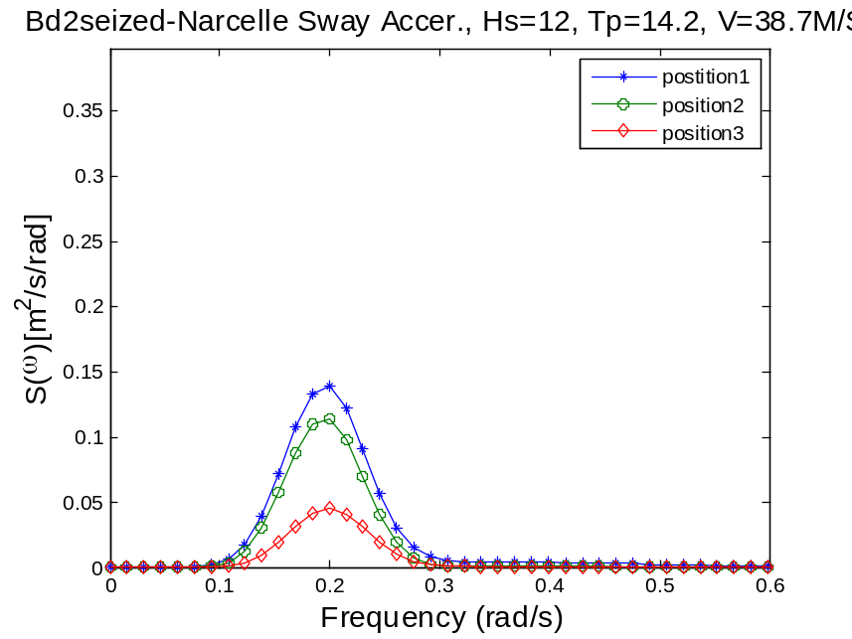
Wp1: roll
Wave dir. 90
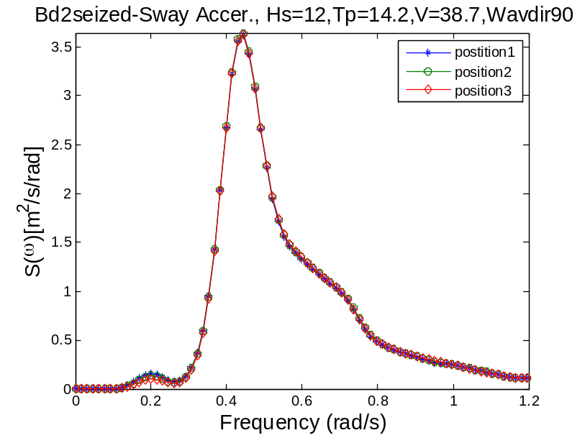
Wave dir0
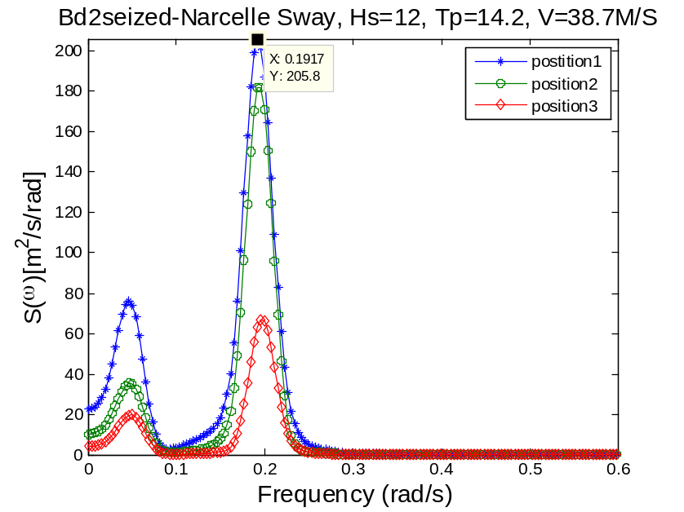

wp1: sway wp2: roll nat. freq.
Wave dir. 90
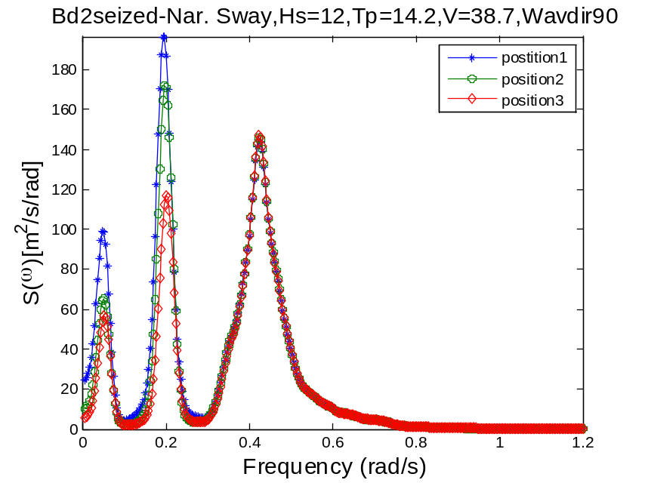
roll and sway are coupled
The symmetrical position3 result in least responses
Wave dir. 0

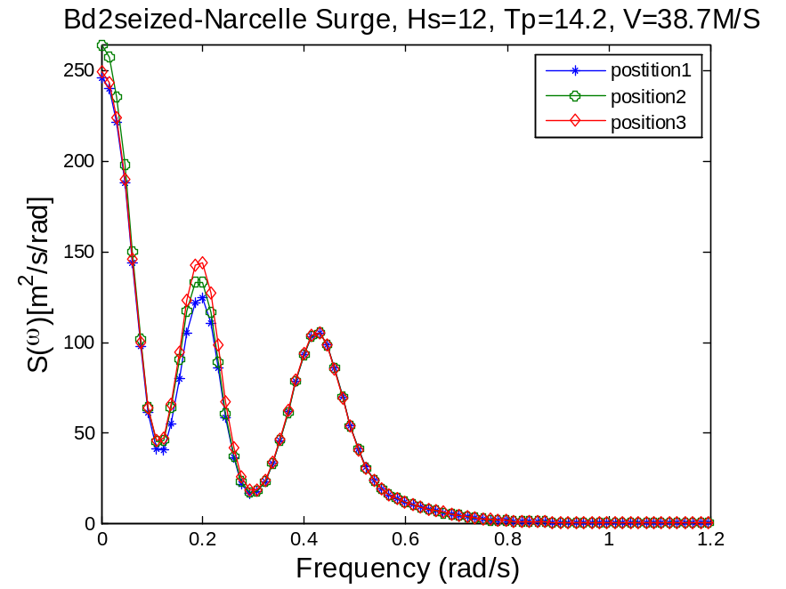
Wave dir. 90
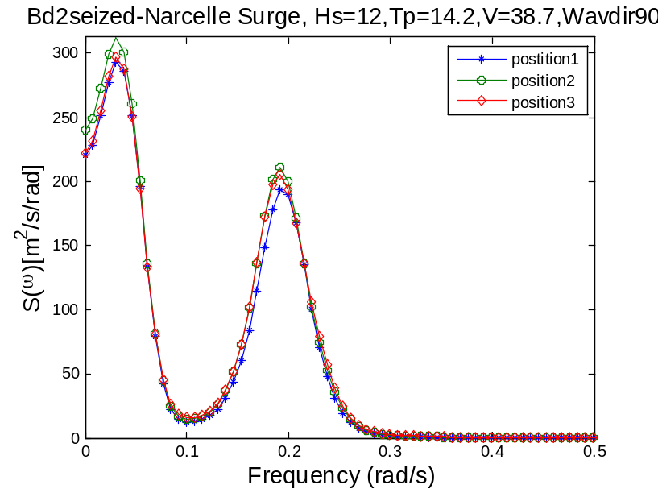

Wave dir. 0

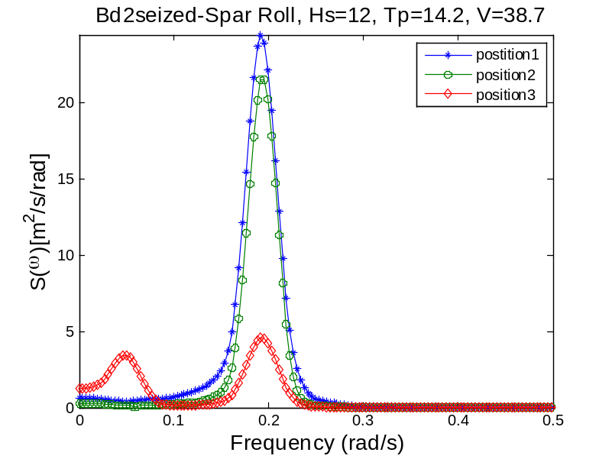
The sway resonance is present in the response of roll motion due to the symmetry position of the blades.
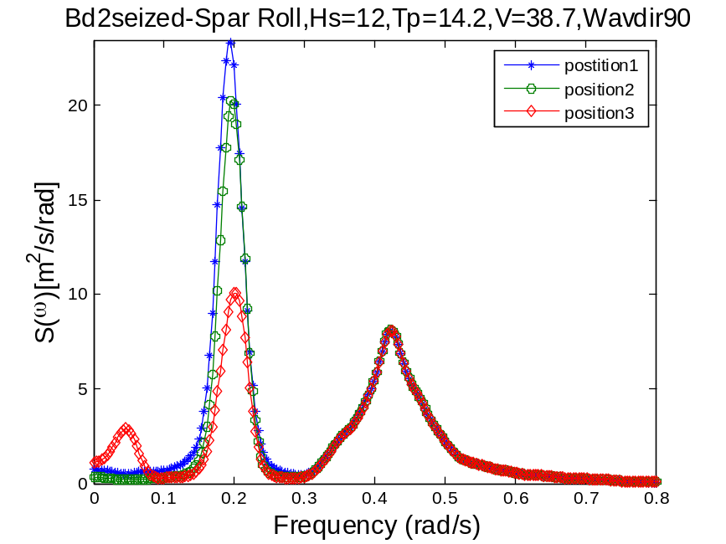
The sway resonant frequency is present in position3. The roll resonant peak of position3 is significantly smaller than that of position1 and 2. The wave frequency part keeps unchanged.
Wave dir0
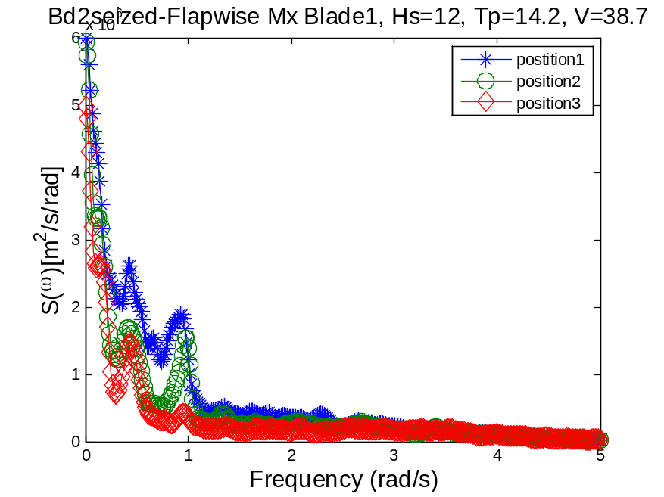
Wave dir90
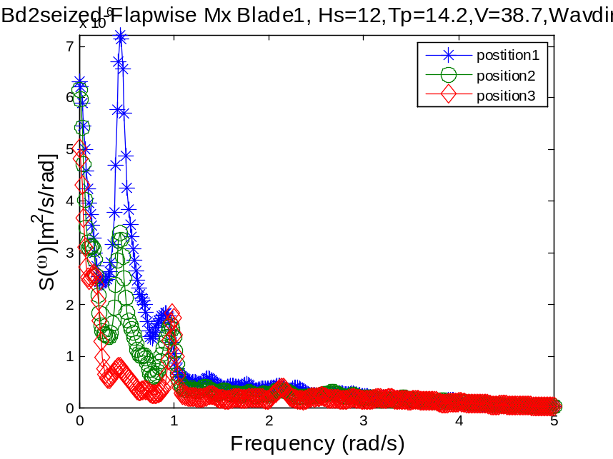

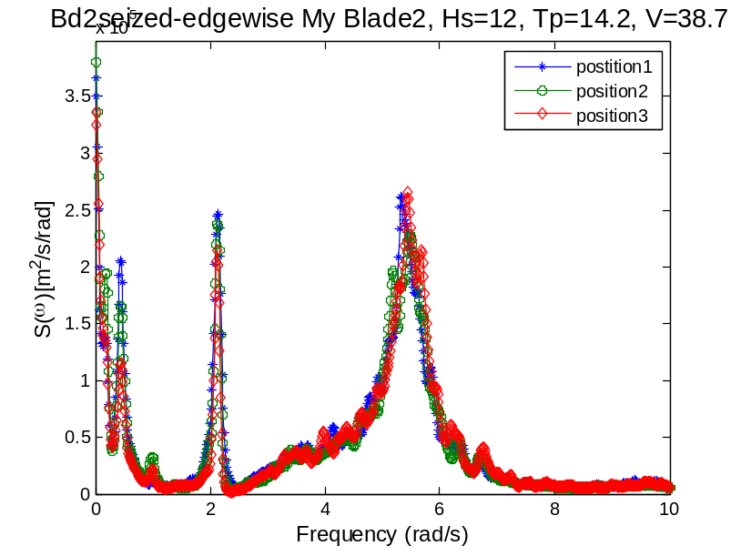
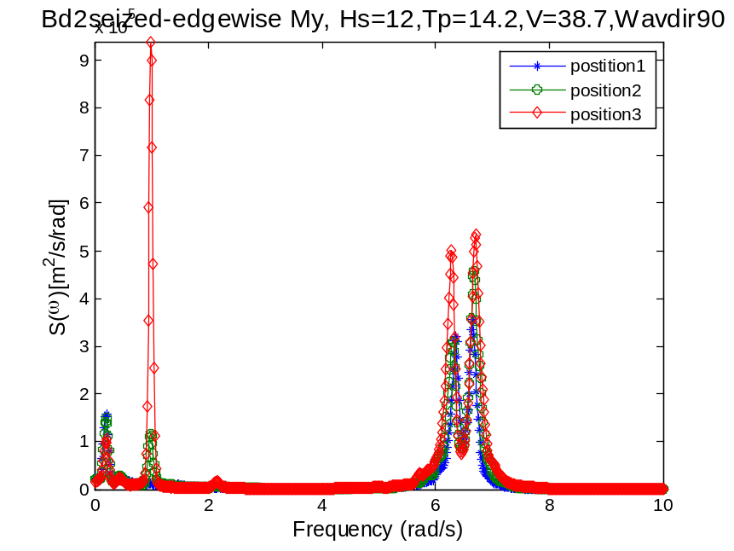
The edgewise response of blade2 has significantly large resonance for position3. Because there is larger aerodynamic loading on it. 1Hz
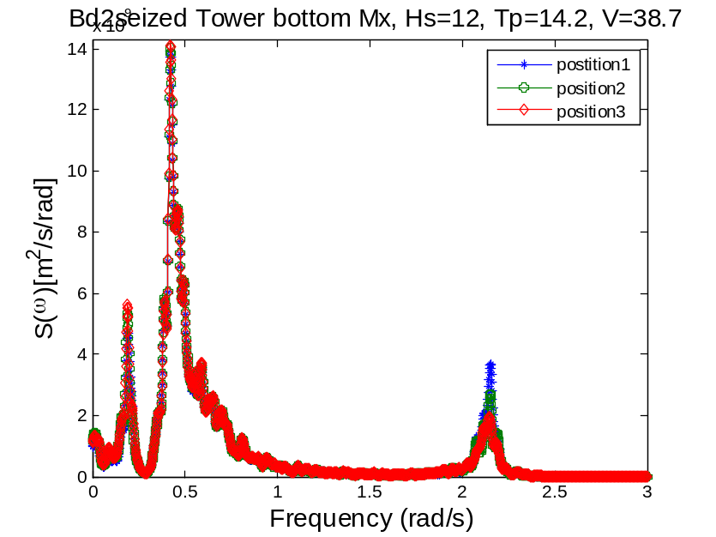
wp1: pitch, wp2: wave freq.
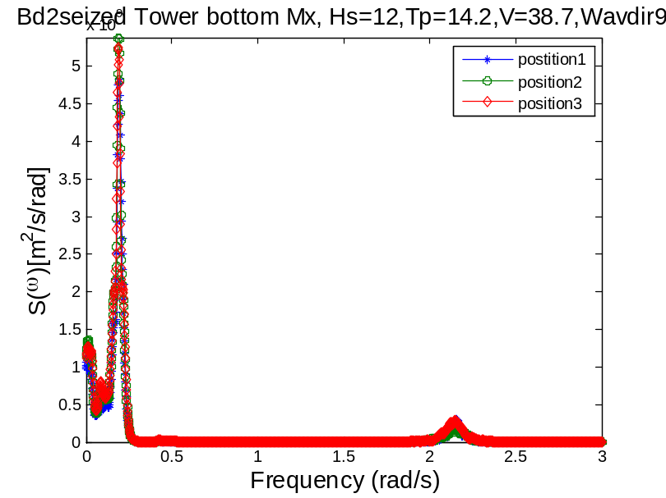
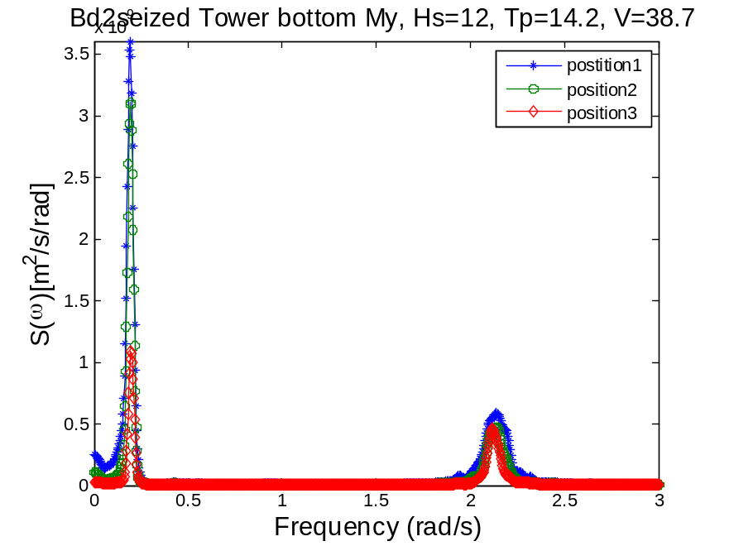
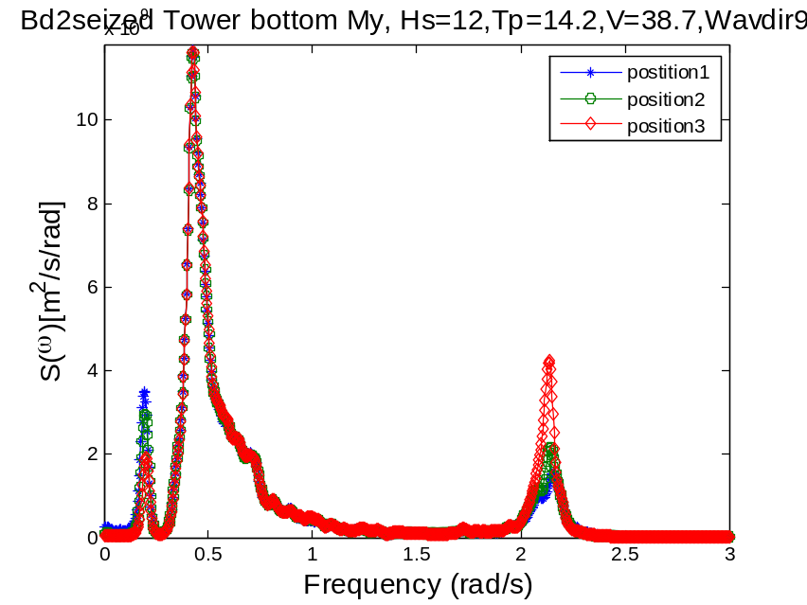
Wp1=0.2 roll

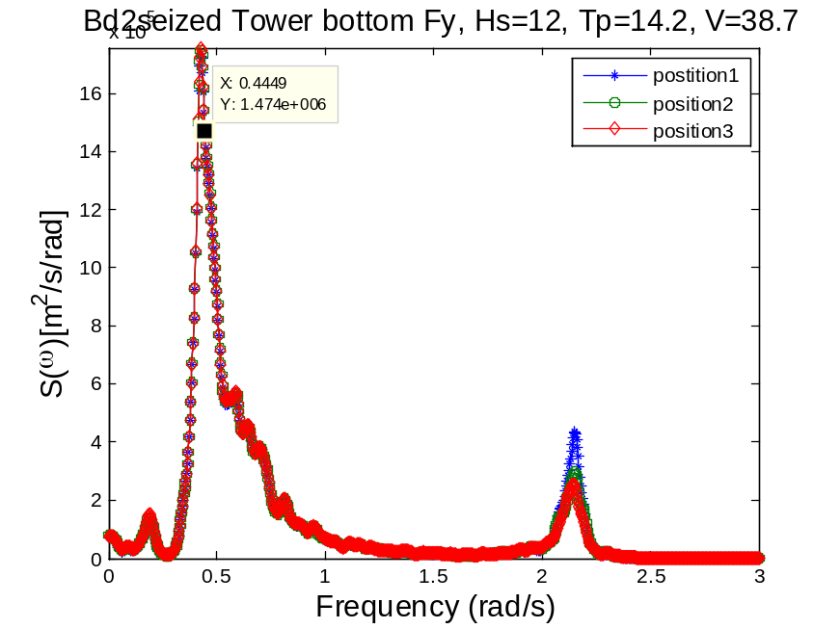
wp1=0.2 pitch, wp2=0.44, wave, wp3=2.15, first tower fore-aft
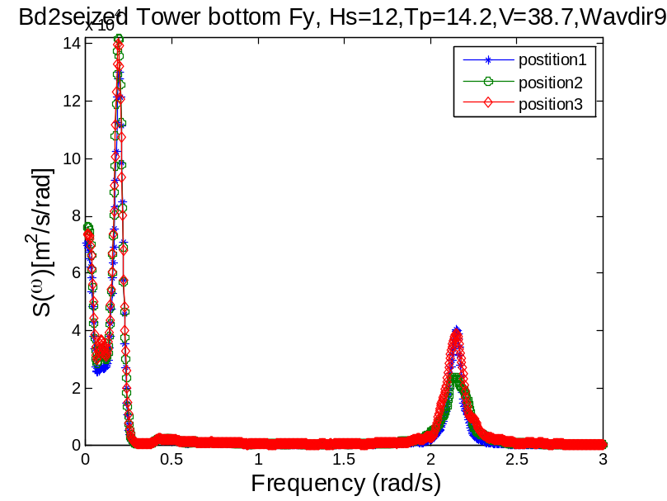

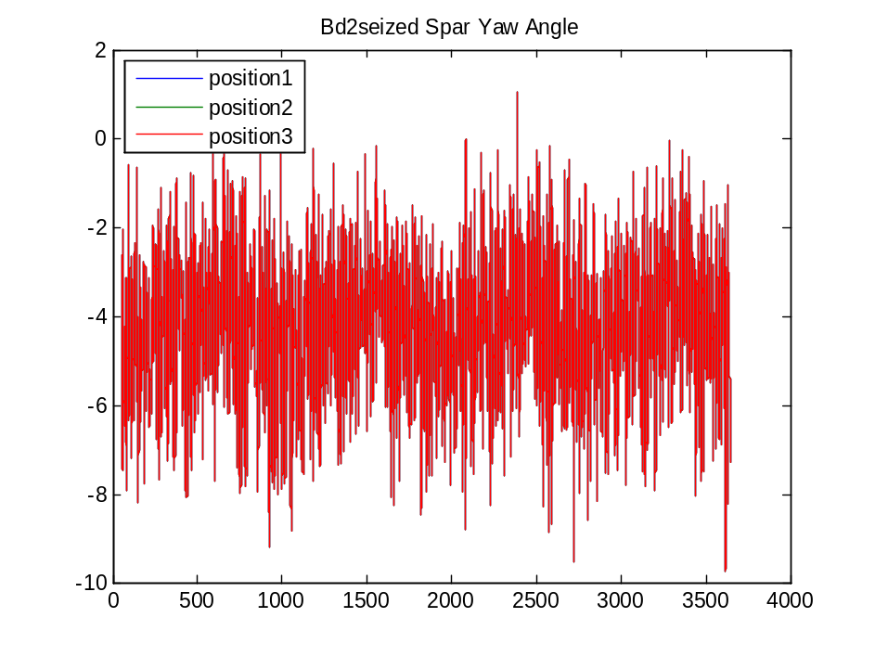
Wave dir0
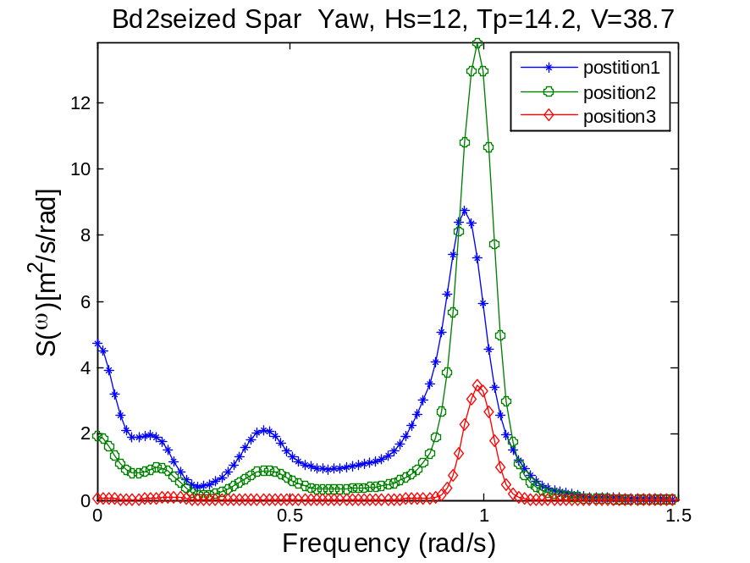
For position1, Wp1=0.15 (roll), wp2=0.44, wp2=0.95(yaw)
Wave dir90
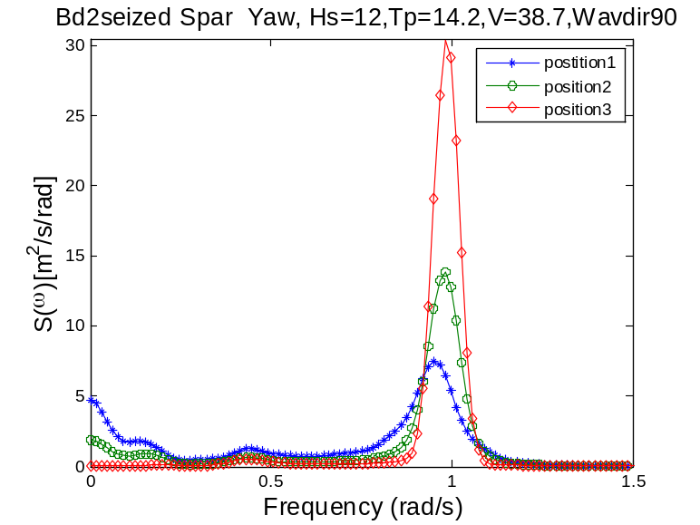
Yaw resonance response is highly sensitive to the azimuth angle of the blade as well as the wave direction. The wave resonant response is largely damped out by the feathered blades 1 and 2.
Wave dir0
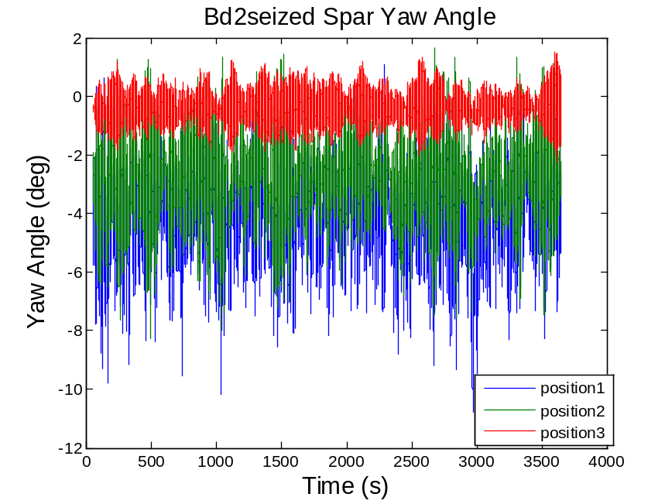
When blade2 is seized, wave-induced response is present in the yaw spectrum of postion3, not in position1 and 2. Since aerodynamic damping of position 2 is largest due to the relative out-of-plane motion of the blade2.
Wave dir90
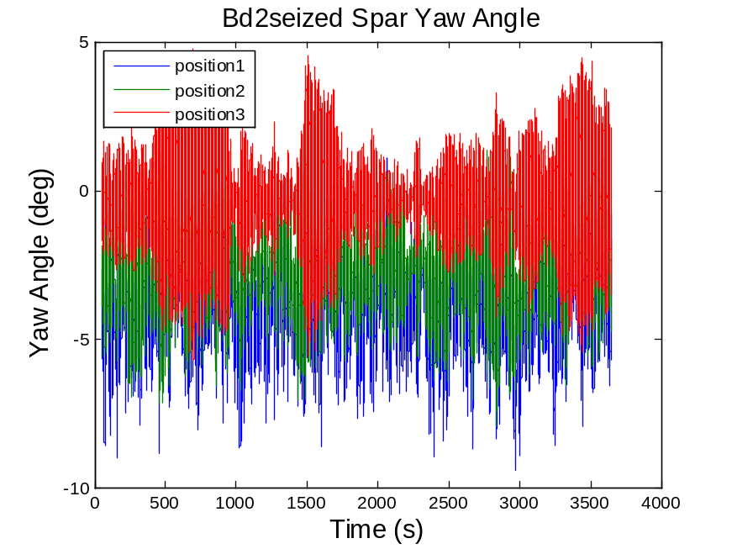
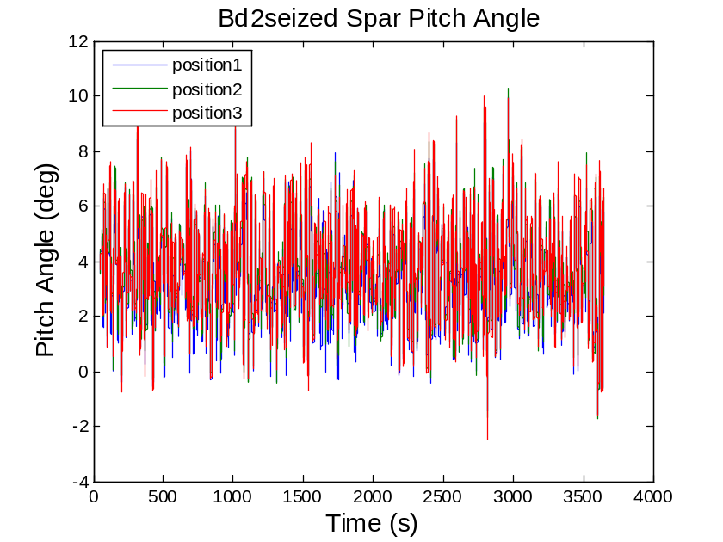
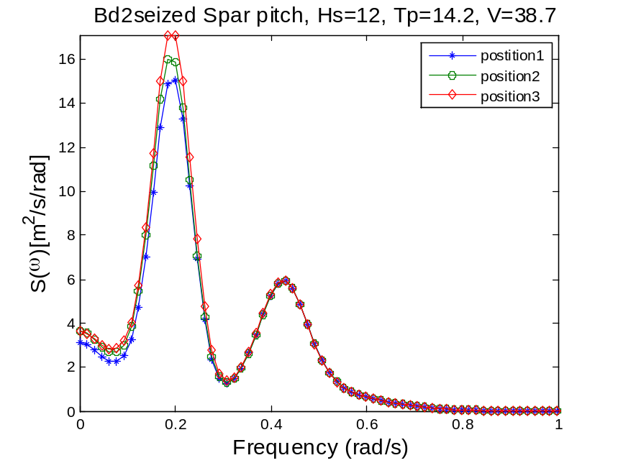
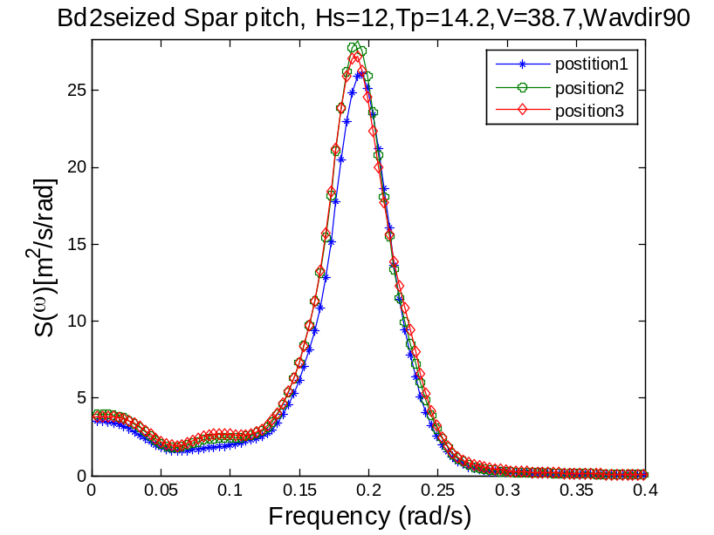
The pitch spectrum is least sensitive to the azimuth position.
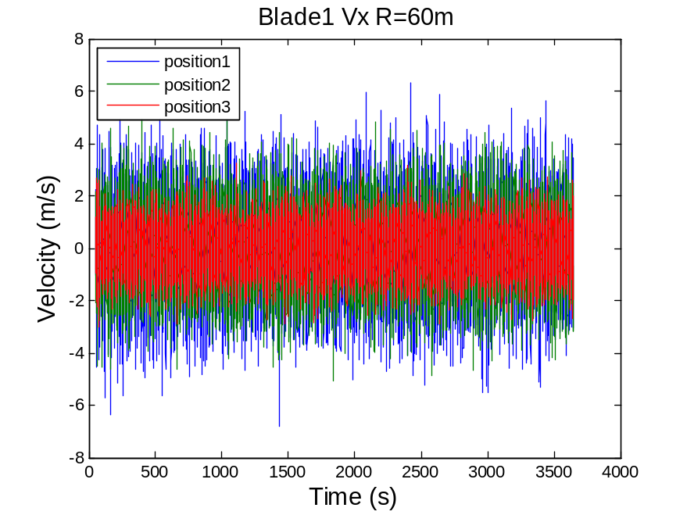
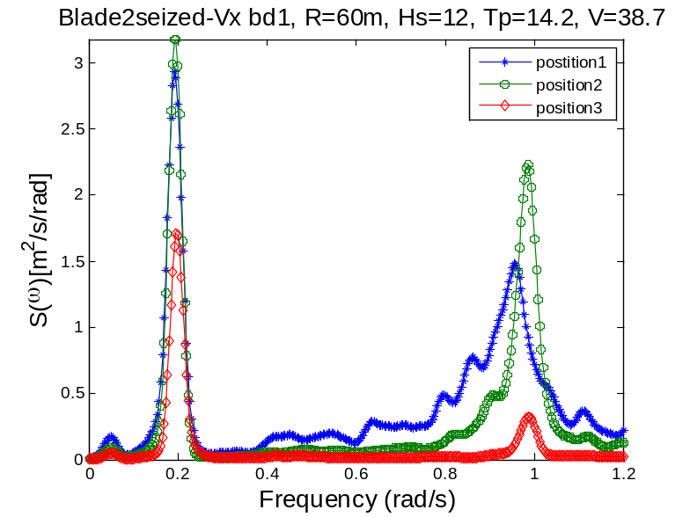
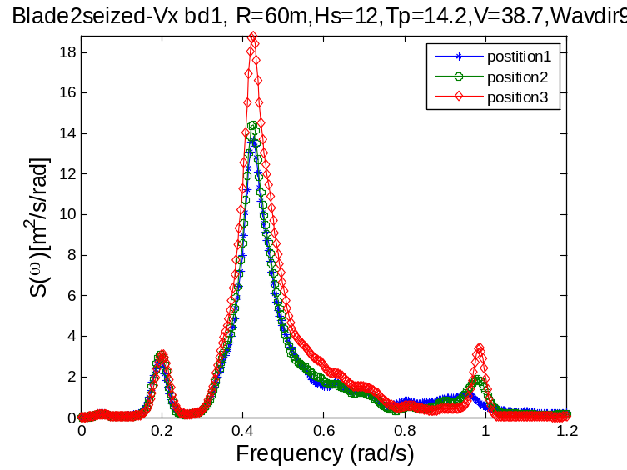
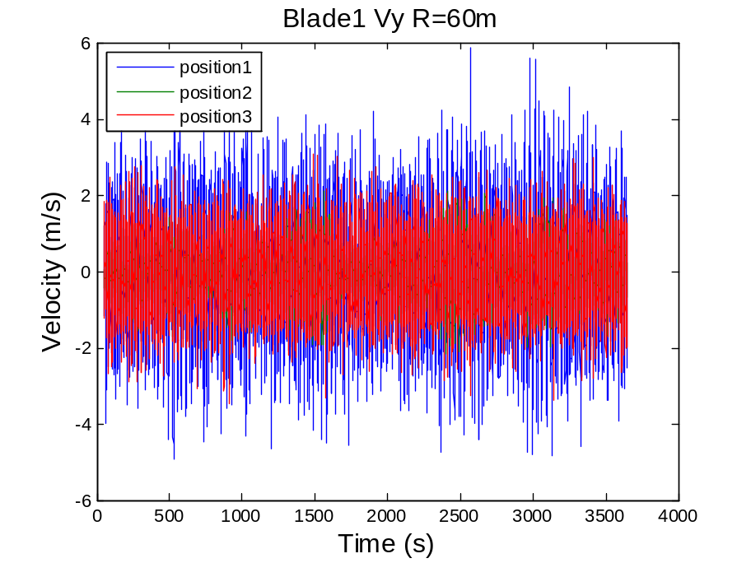
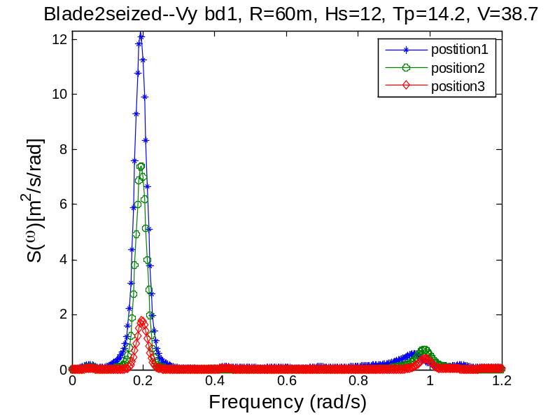
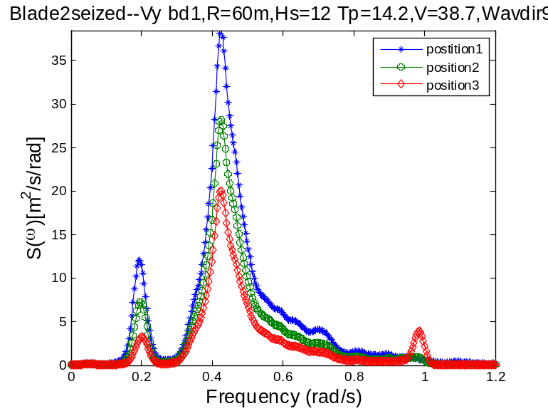

Observations of case 2
For the seized case, nacelle sway acceleration and displacement is very sensitive to the azimuth angle. Since when blade2 is seized, the aerodynamic loads in –x direction come from the lift force of blade1 and blade3 only. Position 1 induces the largest sway motion due to ? The out of plane and in-plane tip speed of blade1 is also sensitive to the azimuth angle. T.
Nacelle sway is sensitive to the azimuth angle is the wave direction is 0 because sway is coupled with roll motion. The sway motion is less sensitive to change of blade position if wave direction is 90. Surge motion is largely unaffected by the azimuth angle. The sway resonant frequency is present in position3, but not in position1 and 2. The roll resonant peak of position3 is significantly smaller than that of position1 and 2. The wave frequency part keeps unchanged.
The blade2 edgewise moment My is connected with the roll and sway motion and hence is sensitive to the azimuth angle. Yaw resonance response is highly sensitive to the azimuth angle of the blade as well as the wave direction. P3 gives the lowest response of yaw motion due to the symmetric aerodynamic drag loading about the tower axis. P1 could be the most critical one which results in the largest responses among three. The mean yaw angle is -4.2 deg. The turbine is moving in this tilted position. Due to the large yaw stiffness provided by the delta line, no instability is found.

When the wave direction is 0, position 3 offers largest aerodynamic damping and reduces the wave resonance most. When the wave direction is 90 deg, The wave resonant response is largely damped out by the feathered blades 1 and 2. Pitch response spectrum, like the feathered case, is least to the azimuth angle of the blades.

